3D PAWS Evaluation
Ankara Site Visit: Maintenance and Condition Assessment. 1/17/2024
Tasks conducted:
Dismantled and cleaned the 3 rain gauges.
Reassembled the rain gauges and added a rain gauge stabilizer to each station.
Dismantled and cleaned the 3 radiation shields.
Changed the temperature, pressure and humidity sensors in station 2.
Replaced the HTU 21D humidity sensor with the SHT 31D sensor in station 2.
Replaced the anemometer base on station 2.
Downloaded all data from the Raspberry Pi SD cards.
Updated the Raspberry Pi software on all stations.
- Overall Condition
All three stations showed signs that they had received little maintenance in the last year. The rain gauges in particular were dirty and only one could be considered “level”. The anemometer sensor on station 2 had developed a short circuit that was tripping the Raspberry Pi, so it had been disconnected; all the anemometers and wind vanes were spinning freely; the inside of the data logger boxes were clean and dry. The radiation shields were somewhat dirty although this likely did not affect performance.
- Rain Gauges
Station 0 rain gauge was significantly off level and may have been “stuck” on one side because of this.
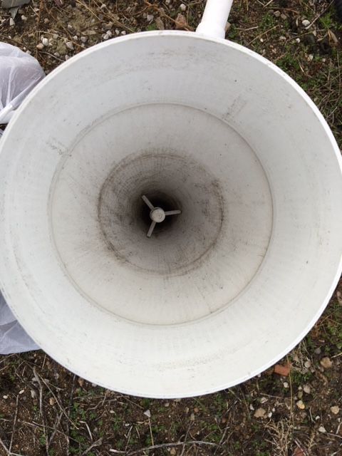
Photo 1. Station 0 rain gauge before dismantling.
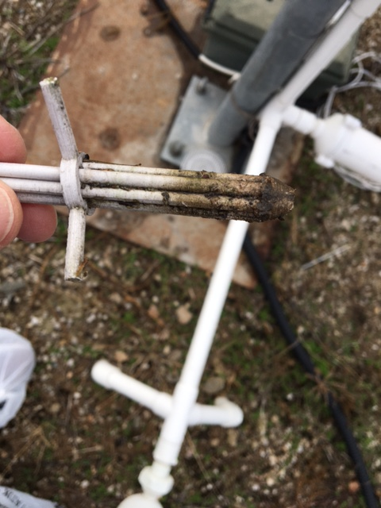

Photo 2. Station 0 vertical screen before cleaning
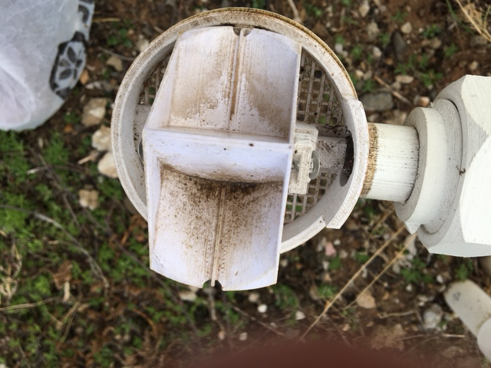
Photo 3. Station 0 bucket before cleaning

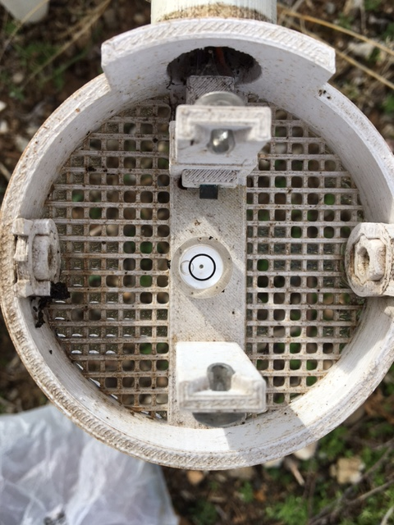
Photo 5. Station 0 level
One side of the bucket in station 1 rain gauge was much dirtier than the other, again suggesting that the bucket was “stuck”, although the level indicator, while slightly off center, did not really indicate this.
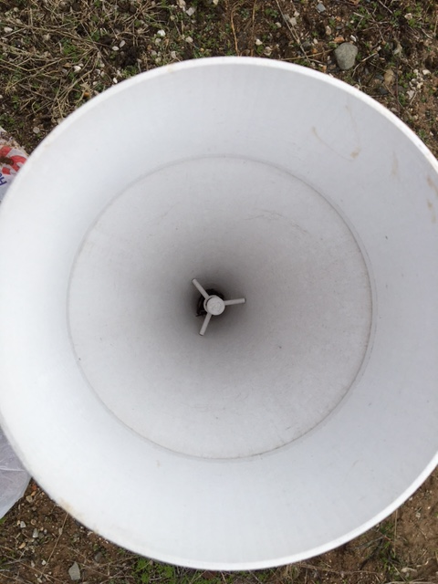
Photo 6. Station 1 rain gauge before dismantling

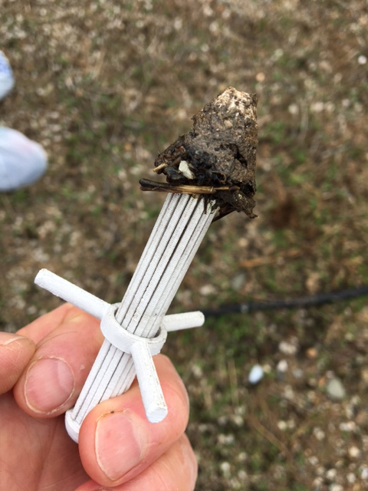
Photo 7. Station 1 vertical screen

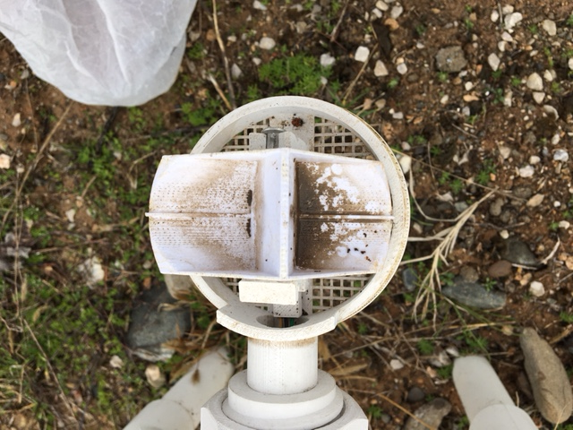
Photo 8. Station 1 bucket before cleaning

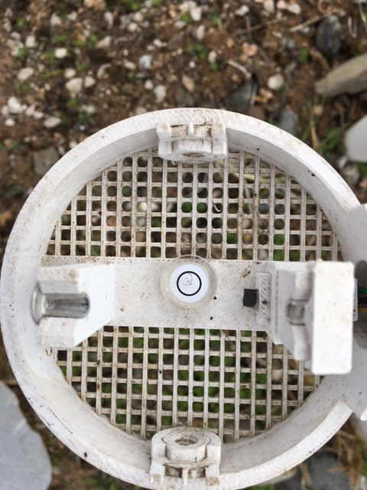
Photo 9. Station 1 level
Station 2 rain gauge was dirty but was mostly level.

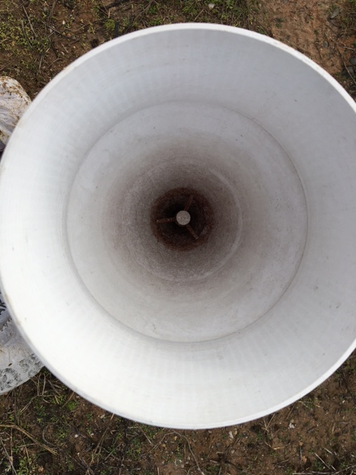
Photo 10. Station 2 rain gauge before dismantling
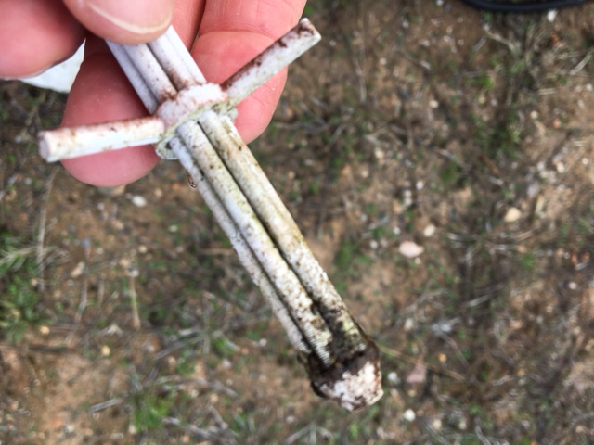
Photo 11. Station 2 vertical screen
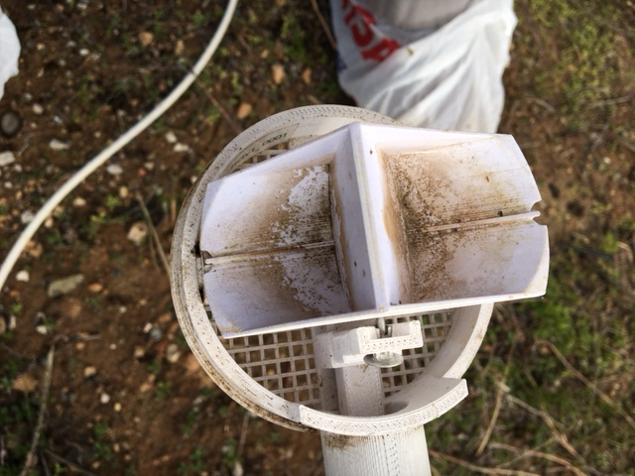
Photo 12. Station 2 bucket before cleaning
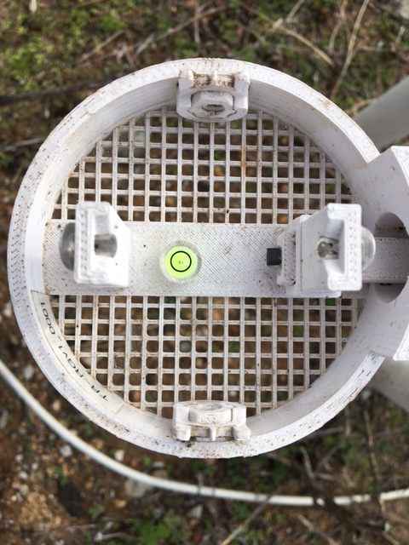
Photo 13. Station 2 level

- Adding Rain Gauge Stabilizers
All three gauges were fitted with the new rain gauge stabilizer after they were reassembled. The stabilizers prevents loss of level due to rotation of the rain gauge about the leveling joint, which has been observed at some installations.

Photo 6. Gauges with Stabilizer
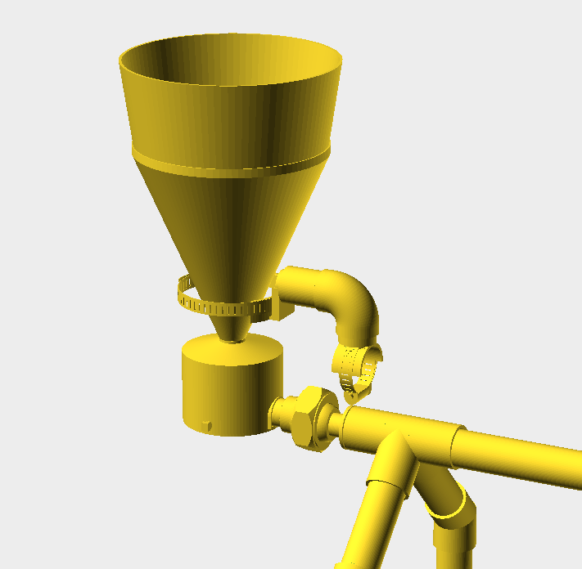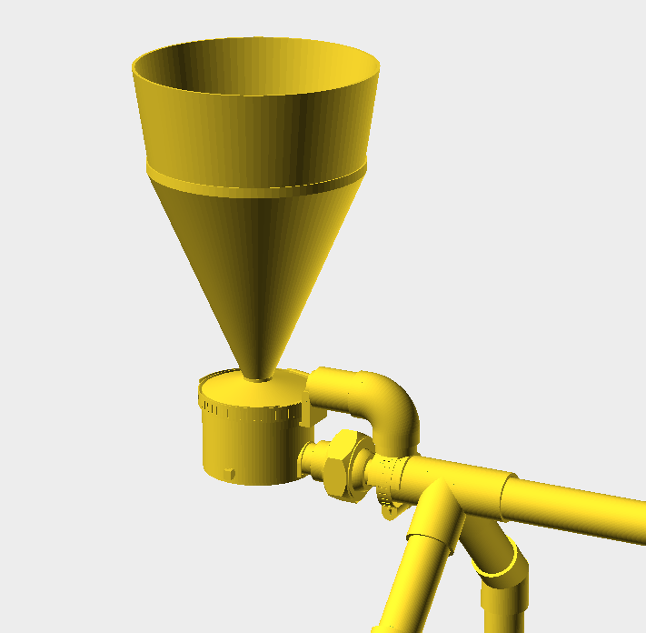
Illustration 1. Details of the Rain Gauge Stabilizer

- Radiation Shields
All the radiation shields were disassembled and cleaned using a soft toothbrush; all components cleaned up well and showed no significant deterioration or discoloration.
- Radiation Shield Harnesses
Station 0 radiation shield harness was built using the original style sensors without Qwiic connectors. No replacement sensors were immediately at hand, so the harness was left untouched. Station 1 harness did have the qwiic sensors but they were also left in place to maintain a baseline. Changes were only made to Station 2 harness; new sensors were installed and the HTU 21D was replaced by an SHT 31D.
- Anemometer base replacement
The anemometer on station 2 had developed a short circuit which was tripping the Raspberry Pi. The problem was found to be with the sensor, so the base was replaced and the original rotor reinstalled.
- Data Download
All data recorded by the 3D PAWS stations are saved to an on-board SD card as a backup in case of loss of the communications link. All data that had been saved to the SD card during the last 17 months was downloaded from the Ankara stations during the maintenance visit.
- Software upgrade
The Raspberry Pi software was upgraded to the latest version on all three stations.

